Project deliverable 4

Uzer Mohammed
Advanced Big Data and Data Mining (MSCS-634-M20) - Full Term
University of the Cumberlands
Dr. Satish Penmatsa
July 25, 2026

Introduction
Breast cancer is still one of the biggest killers in the world for women. Early diagnosis can greatly enhance the chances of successful treatment and better patient survival. With the help of machine learning and data mining techniques, healthcare professionals have been able to analyze complex medical data and create predictive models that help in the diagnosis of diseases. The Wisconsin Breast Cancer Diagnostic Dataset is used in this project to find patterns in the data that are related to benign and malignant breast tumors. Data preprocessing, exploratory data analysis, feature engineering, classification, clustering, and association rule mining are all part of the project, which aims to extract meaningful insights to aid clinical decision-making. The results show that predictive analytics can enhance the accuracy of diagnosis, but also raise ethical concerns regarding data analysis in healthcare.
Dataset Used and Why It Was Chosen
Wisconsin Breast Cancer Diagnostic Dataset was chosen as one of the most commonly used benchmark datasets for medical classification research. The data set contains 569 observations of patients and 32 attributes that are extracted from digitized images of fine needle aspirate samples of breast masses. The observations are labeled as malignant or benign, and the data set is suitable for supervised machine learning classification problems.
This dataset was selected because it is a real world healthcare problem, in which accurate diagnosis is crucial. The numerical characteristics of the tumor such as radius, texture, perimeter, area, smoothness, compactness, concavity, symmetry and fractal dimension are sufficient to model the tumor. Also, the data set has very few data quality issues, so that more time can be dedicated to the development and evaluation of the model than to data cleaning. The dataset has a high clinical value due to the importance of breast cancer diagnosis, making it a good example of the use of data mining techniques in medical decision making.
Data Preprocessing
Data preprocessing was done to prepare the data for machine learning analysis. The data set was first scanned for missing data, duplicate data and inconsistencies. There were no missing data values or duplicate observations found, which suggested that the data was well organized and complete. Before building models, descriptive statistics and data types were examined for each attribute to verify that they are of integrity.
The diagnosis outcome was recoded as a binary variable (malignant tumors coded as one and benign tumors coded as zero) for the target variable. The technique of StandardScaler was used to standardise all predictor variables as many machine learning algorithms are sensitive to the scale of the features. The standardization made sure that every feature was equally important when the model was being trained and helped to keep the variables with higher numbers from having a greater influence on the learning process. Finally, the data was divided into training and testing sets, using 80% of the data for training and 20% for testing, to evaluate the performance of the models on unseen data.
Exploratory Data Analysis (EDA)
Exploratory Data Analysis was performed to gain insight into the data set's properties and relationships prior to building the model. The class distribution was benign>malignant with adequate sample size to support predictive modelling for both classes. The histograms revealed that there were features whose distributions were different for benign and malignant cases, and hence good discriminatory power.
The correlation heatmap showed that there were some variables related to tumor size and shape that were highly correlated. The worst radius, the worst perimeter, the worst area, the mean concavity and the mean concave points were particularly good positive correlations. These relationships indicate that larger tumors are more irregular in shape and are more concave, which are characteristics of malignant tumors. Several important features also had more variability and higher median values for the malignant observations than for the benign observations, which further suggested differences between the benign and malignant observations (boxplots). In general, exploratory analysis showed that there are meaningful patterns in the data that can be used to develop very accurate predictive models.
Feature Engineering
The main focus of feature engineering was on feature scaling and identifying influential predictor variables. All the numerical variables were standardized so that they could be scaled on the same scale, which made algorithms such as Support Vector Machines and K-Means clustering more effective. After training the model, the feature importance scores obtained from the Random Forest algorithm were used to determine the most important features that predict a breast cancer diagnosis.
The most important variables were: worst radius, worst perimeter, worst concavity, worst area, and mean concave points. These are clinical features of malignancy and relate to the size of the tumour and irregularities of the structure. The identification of these important features increased the interpretability of the model, and also demonstrated the potential of machine learning to highlight medically relevant features that are relevant to the diagnostic decision.
Classification Results
Supervised machine learning algorithms were tested such as Logistic Regression, Decision Tree, Random Forest, Support Vector Machine and Naïve Bayes. The accuracy, confusion matrices, classification reports and receiver operating characteristic (ROC) curve were used to evaluate each model on the testing dataset, while the standardized training dataset was used to train each model.
Random Forest and Support Vector Machine had the best results in predicting the results, with very good classification accuracy and good capacity to differentiate malignant tumors from benign tumors. Logistic Regression also gave a decent performance and again there were a lot of observations that were linearly separable. Simple and easy to understand, Decision Tree and Naïve Bayes were also employed, but with slightly reduced accuracy. The results of the classification analysis showed that the machine learning models could accurately classify the breast cancer diagnosis with minimum classification errors.
Clustering Results
Unsupervised learning was carried out using K-Means clustering algorithm, which is used to detect natural clusters in the data without taking into account the diagnosis labels. Elbow Method and Silhouette Score were used to find the optimum number of clusters. The two evaluation methods both showed the two clusters to be the most meaningful partition of the data.
The resulting clusters were very similar to the benign and malignant diagnosis categories, suggesting that the tumor's characteristics naturally form distinct clusters. There are no pre-defined labels for clustering, however the similarity of clusters to real diagnoses indicates that there are structural differences between breast cancer observations. The results further validate the effectiveness of the features selected for the discrimination of the tumor types.
Association Rule Mining Results
The continuous variables were converted to binary variables with the help of median values and association rule mining was done with the help of Apriori algorithm. Minimum support thresholds were used to generate association rules, frequent itemsets were generated, and association rules were generated based on the confidence and lift measures.
The rules that arose indicated that there were certain common characteristics of tumors. The variables that were always associated with each other were those associated with larger tumour size, higher concavity and irregular boundaries. The relationships validate the explorative data analysis and feature importance evaluation results. Association rule mining does not make predictions, but it can be very useful for understanding the combinations of features that are present in the same malignant tumors, and can help researchers to understand complex relationships between clinical measurements.
Key Insights and Practical Recommendations
The Wisconsin Breast Cancer Diagnostic Dataset was analyzed to show that there are strong patterns in the data that are well suited to be captured using modern machine learning algorithms. In classification, ensemble learning and margin-based classifiers were the best performing methods, with Random Forest and Support Vector Machine being the top two classifiers.
Predictive models created from similar datasets can be used to assist doctors when making diagnoses in healthcare organizations. Machine learning should be used to complement, not replace, clinical decision making. Predictive analytics in health care information systems can help minimize diagnostic errors, ensure uniformity, and help detect breast cancer at an earlier stage. It is recommended to retrain the model regularly with new patient data to ensure the model's predictive performance and adjust to changing patient populations. Moreover, predictive models need to be continually validated in a variety of demographic groups to achieve fairness and generalizability.
Ethical Considerations
One aspect of ethics in healthcare and AI is the use of AI to enhance patient safety. Another ethical consideration in healthcare and AI is the use of AI to improve patient safety. To ensure patient privacy, it is essential to adhere to relevant healthcare privacy laws and regulations and put in place proper security measures during data collection, storage, and analysis. The Wisconsin Breast Cancer Diagnostic Dataset is anonymized, but when organizations deploy predictive models, they need to make sure patient confidentiality is maintained.
Bias is another ethical issue. The predictions from machine learning models that have been developed from small or unrepresentative data sets can be biased for patients with different characteristics. Hence, predictive models should be periodically assessed for fairness by demographic groups, and monitored post-deployment. Moreover, transparency and explainability are key as healthcare professionals need to understand the factors affecting the model predictions before using it in clinical practice. AI should be used in conjunction with human oversight to ensure patient safety and trust in the AI system.
https://github.com/UzerMohammeduc/project-deliverable-4

Code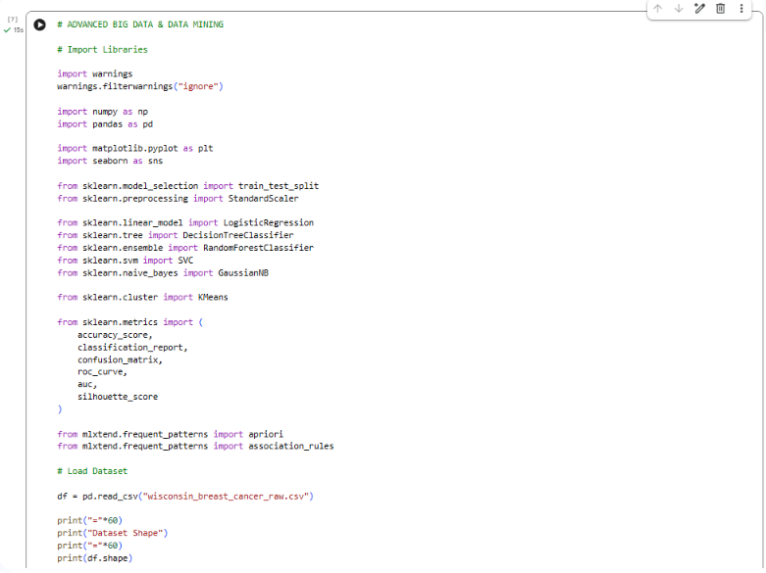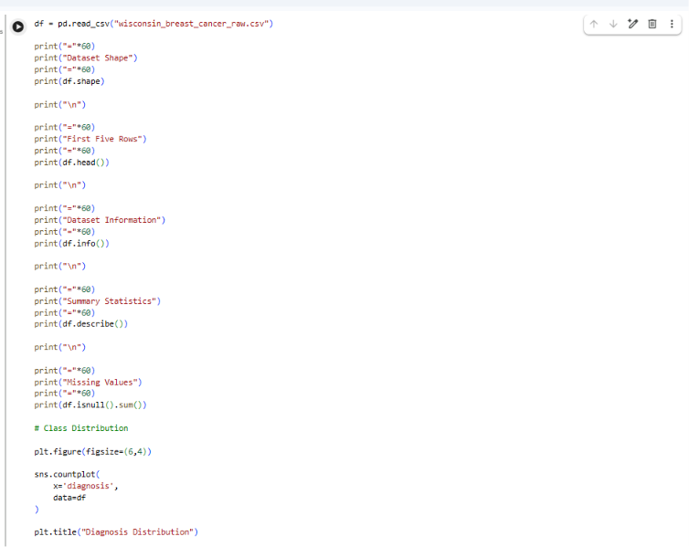
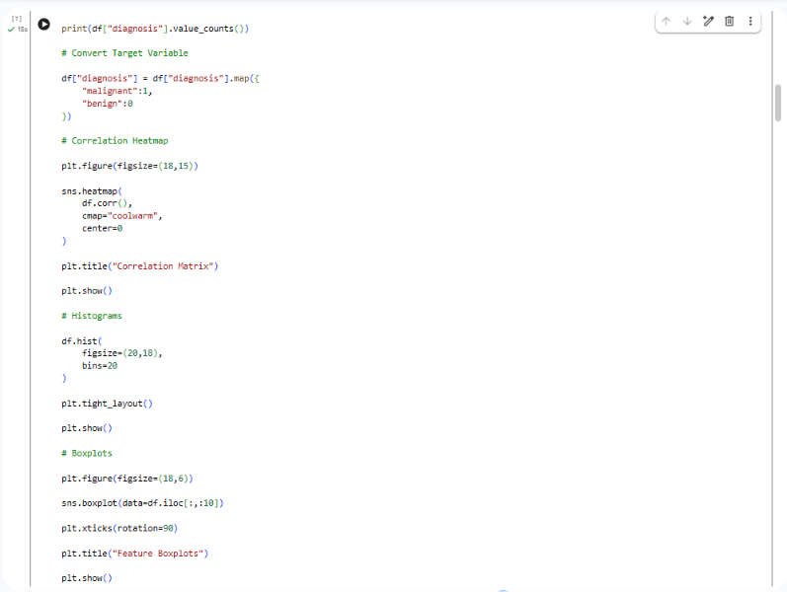
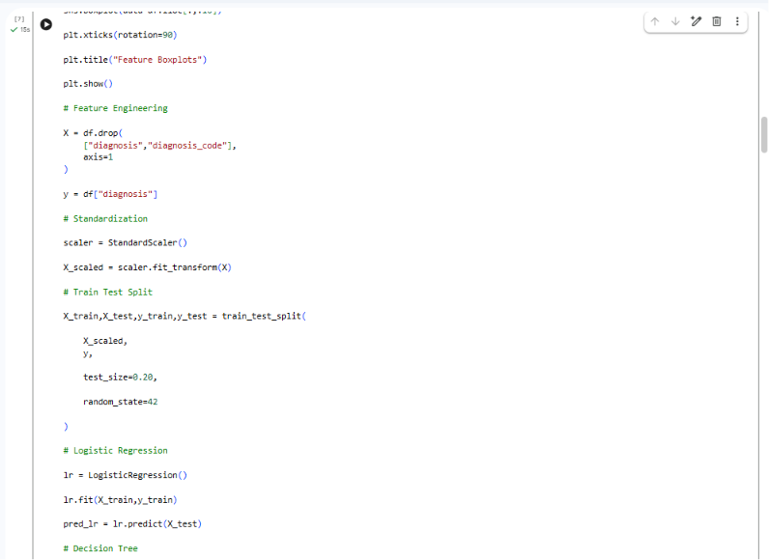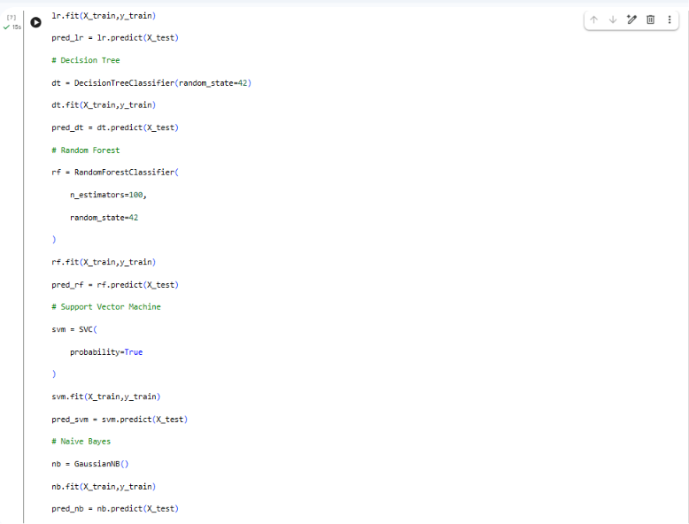
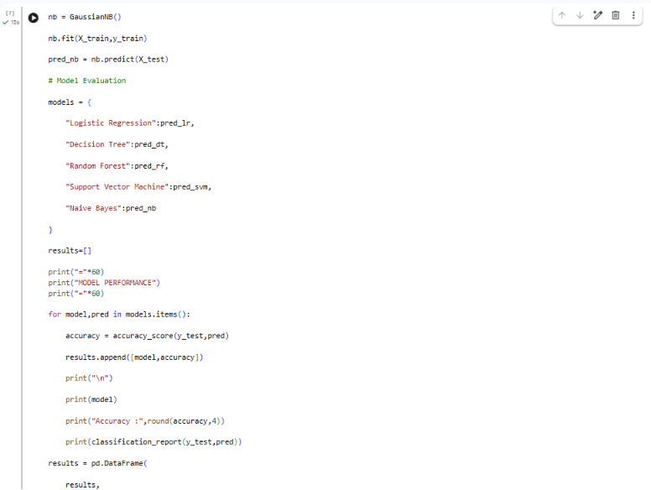
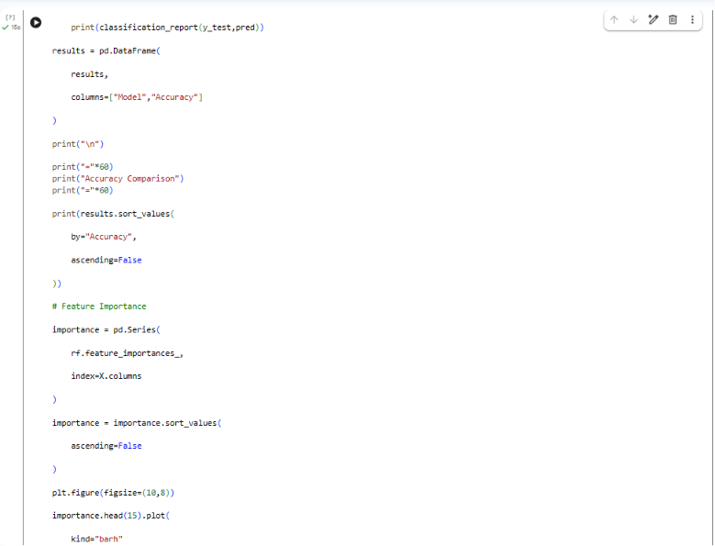
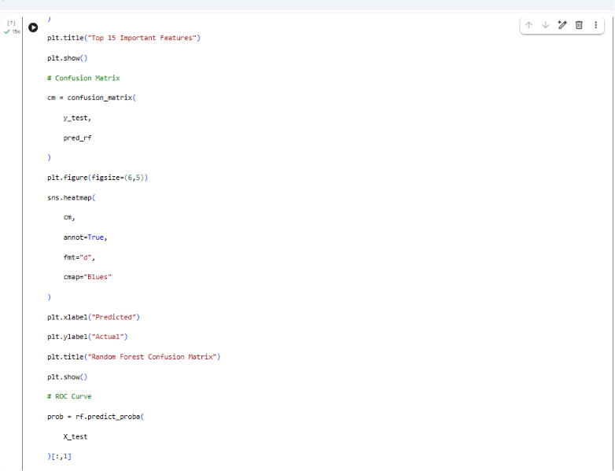
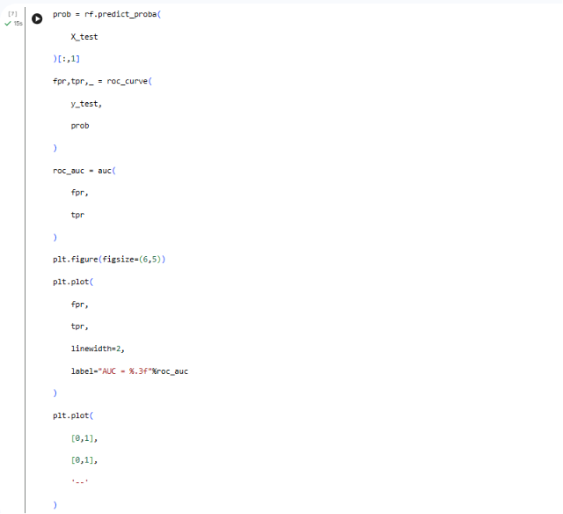
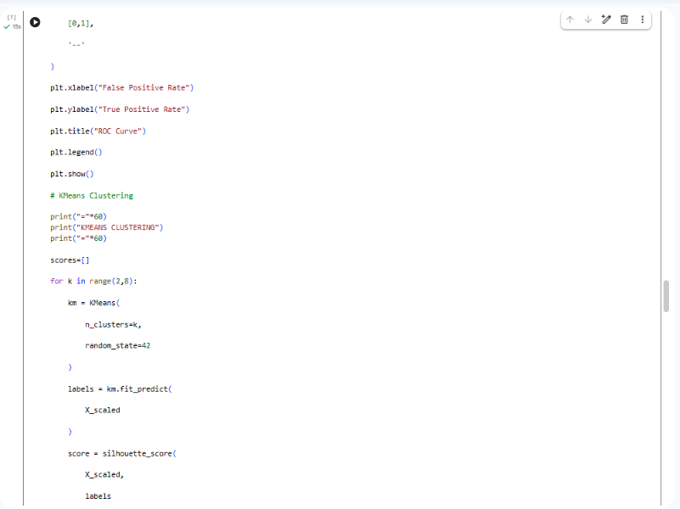
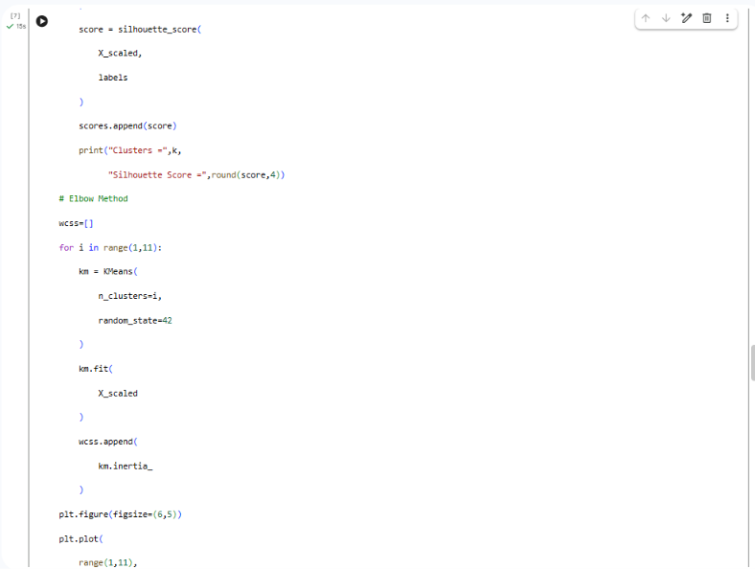
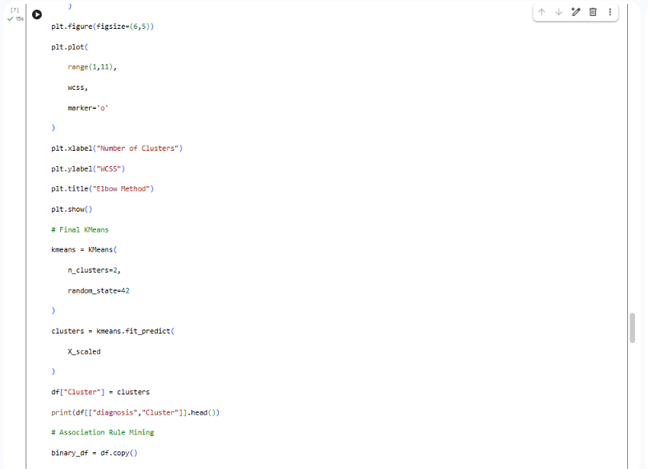
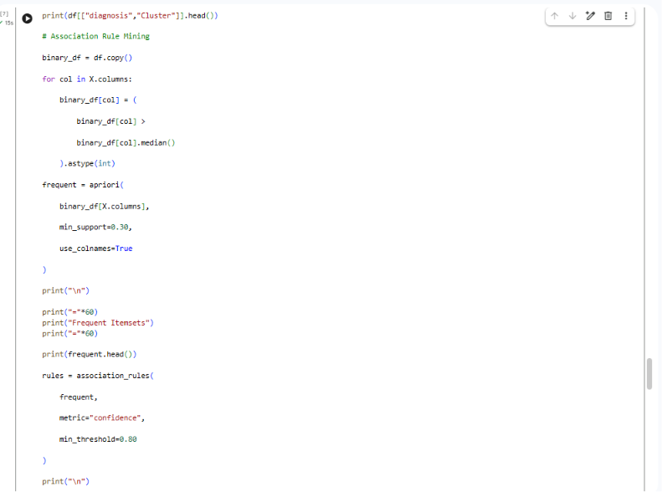
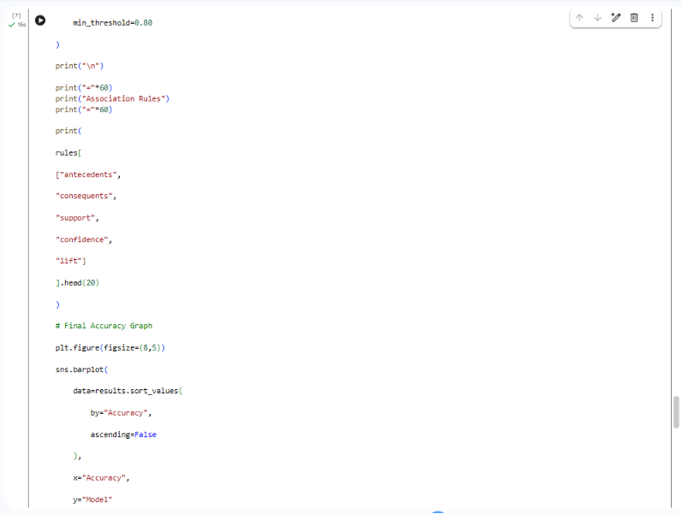
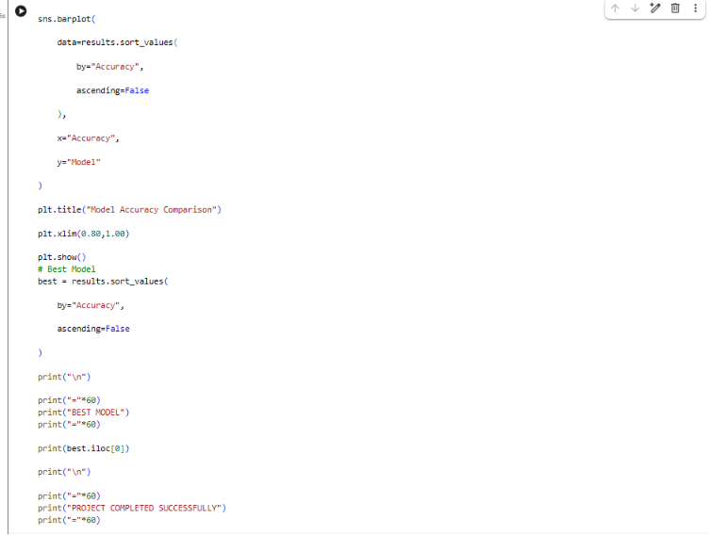
Output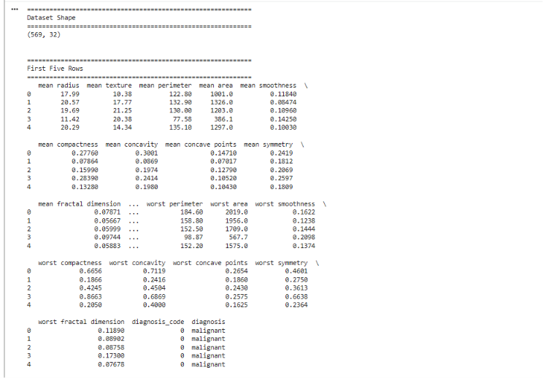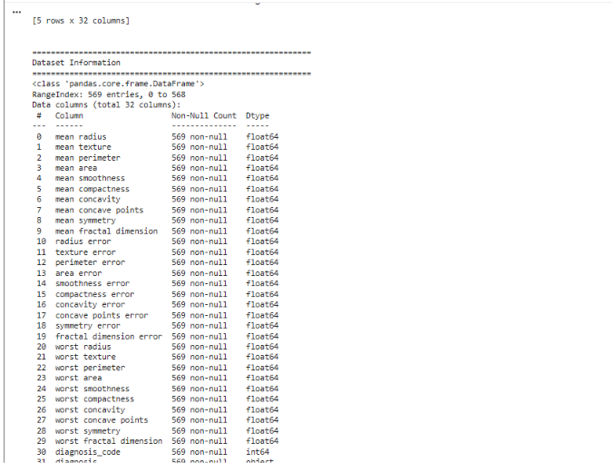
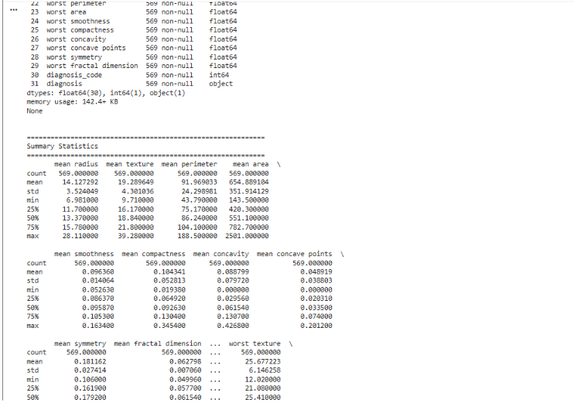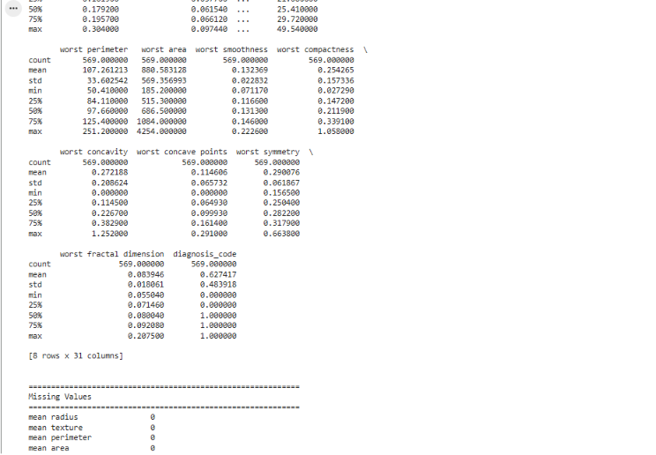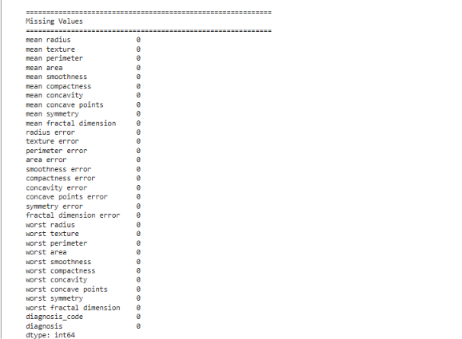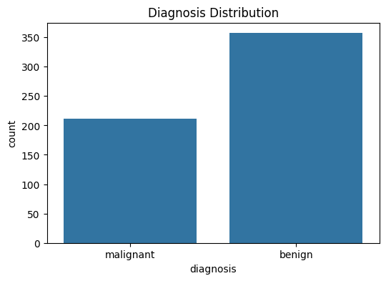
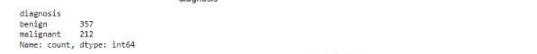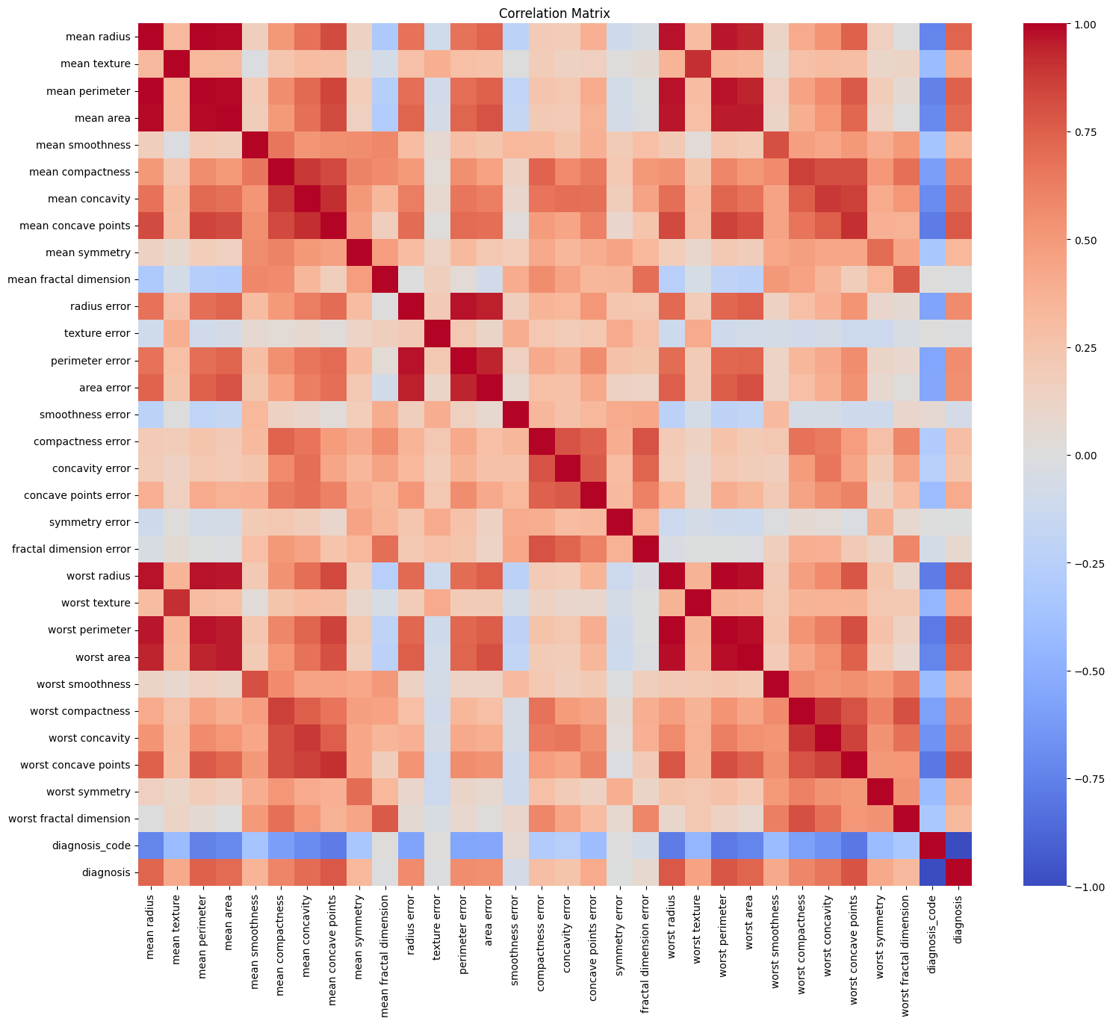
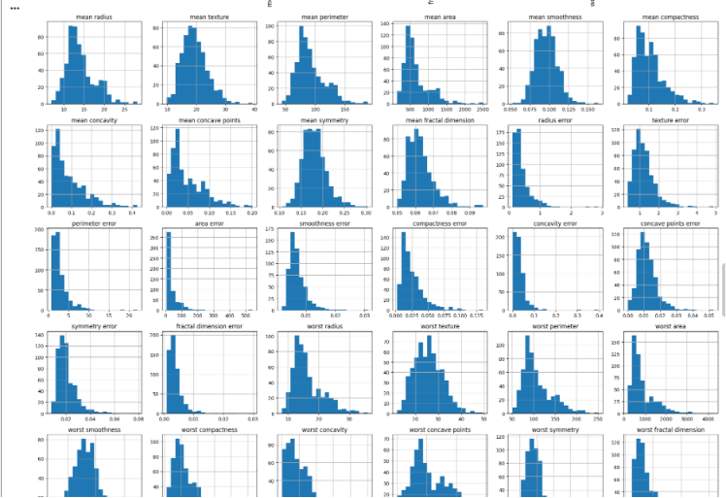
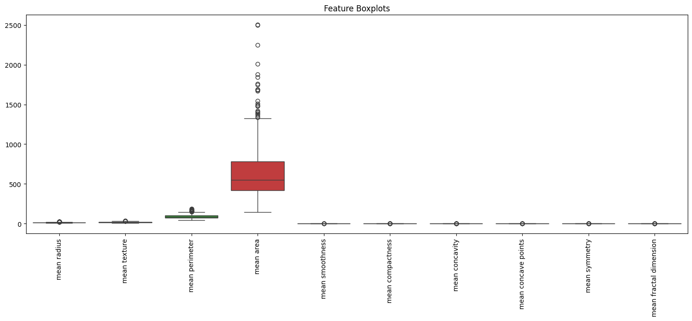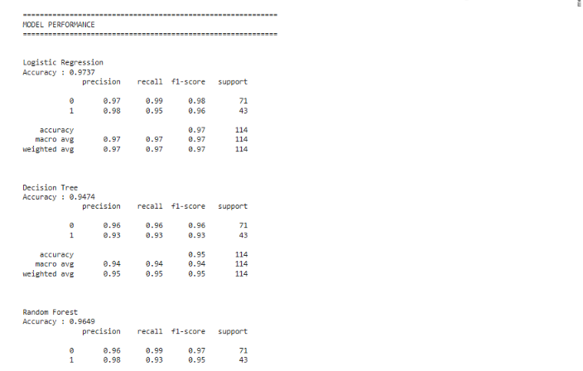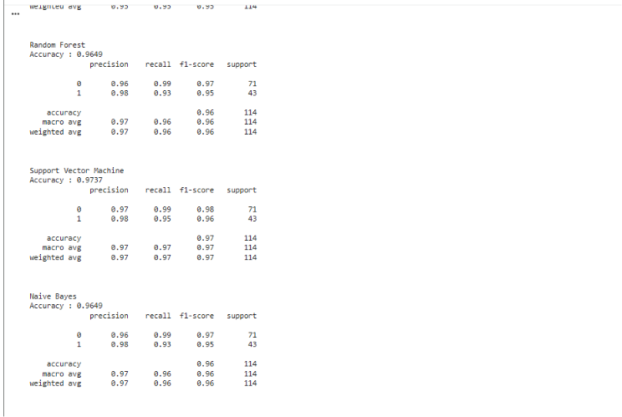
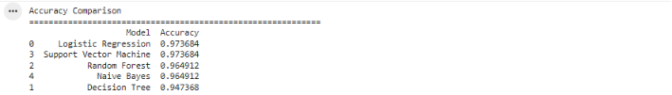
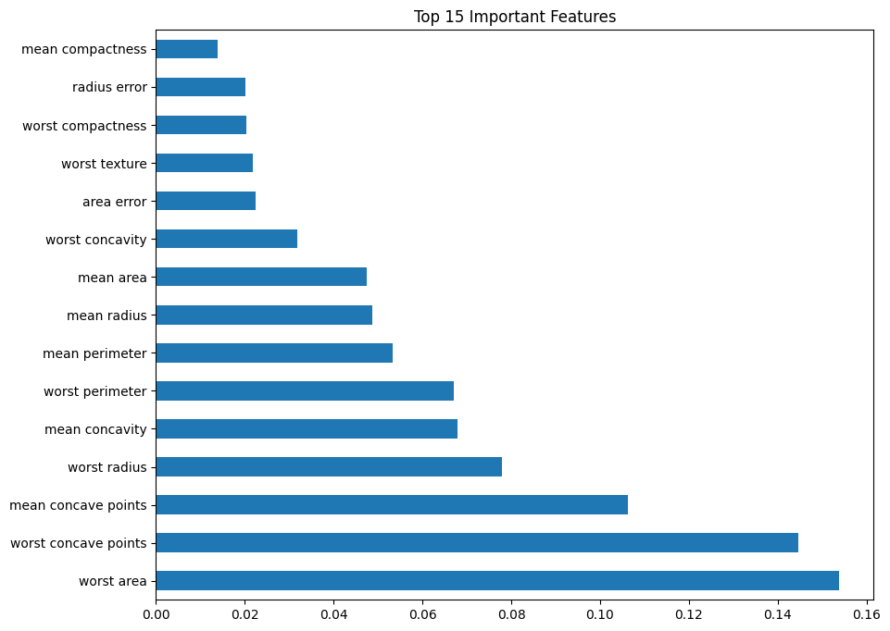
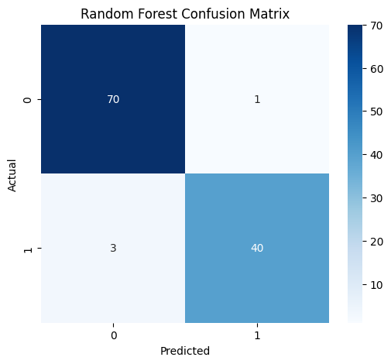
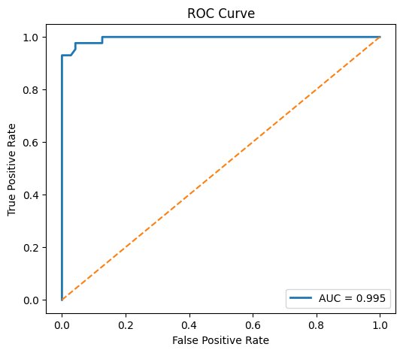
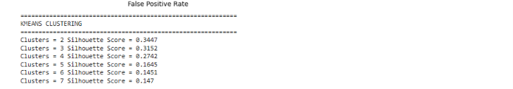
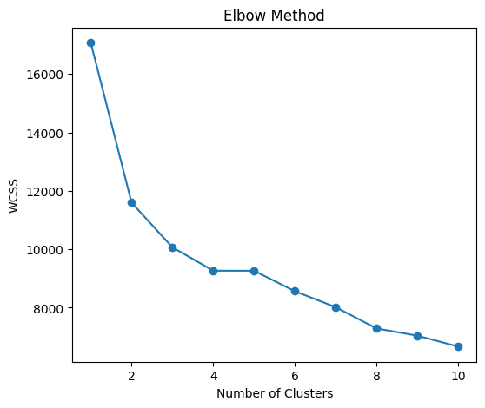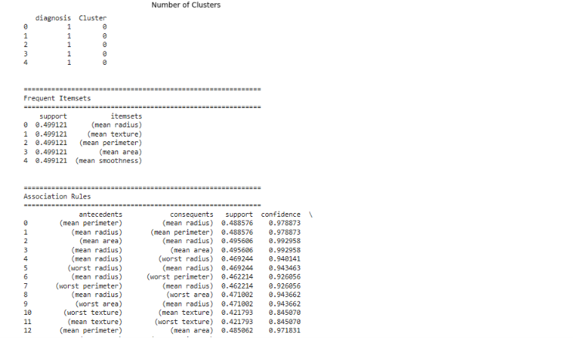
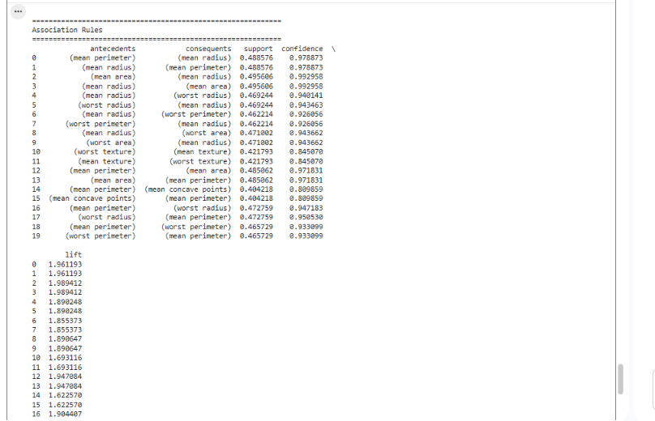
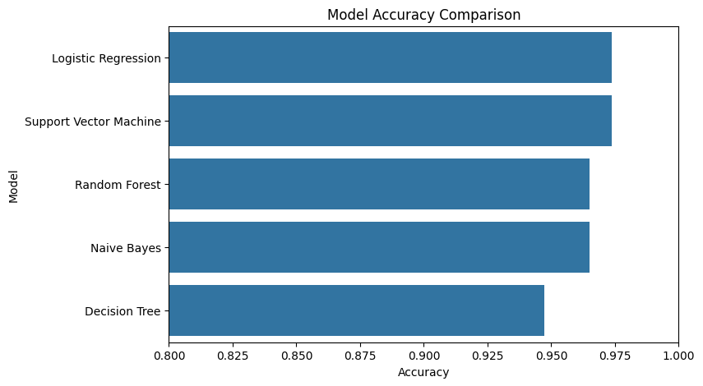
Conclusion
This project showed the successful implementation of data preprocessing, exploratory data analysis, feature engineering, supervised classification, unsupervised clustering and association rule mining on the Wisconsin Breast Cancer Diagnostic Dataset. The results showed that machine learning algorithms were able to accurately distinguish between malignant and benign tumors and identify the most important clinical features for the diagnosis of breast cancer. Random Forest and Support Vector Machine were found to be the best predictive models and clustering and association rule mining were employed to provide additional insights into the structure of the data.
The project demonstrates the great potential of data mining techniques in assisting healthcare decision-making. Although predictive models offer many benefits in terms of accuracy and efficiency, it is essential to consider the ethical, fair, transparent and patient privacy implications when responsibly implementing predictive models. When well validated and applied, machine learning has the potential to be a key tool in improving breast cancer diagnosis and patient outcomes.

